Analyzing Average Local Temperature in Lagos, Nigeria and Average Global Temperature

By

Afamefuna Chidinma

**Introduction**

Nigeria is a country located in West Africa, with GPS coordinates of 9.0820° N, 8.6753° E.

Lagos, a bustling city in Nigeria has a latitude **6.465422 N**, and longitude of **3.406448 E**. Lagos is 445.18 mi (716.45 km) north of the equator, so it is located in the northern hemisphere.

Regions around the equator tend to have a tropical climate and are fairly hot regions. In this type of climates, the temperature remains relatively constant throughout the year and sunlight is intense. Due to its proximity to the equator, it receives about 12 hours of direct sunlight daily for every month of the year even during the rainy season. Also, the temperature range in Lagos is between 21 to 36°C depending on the time of the year.

**Procedure (Steps Taken)**

Step 1

Using a SQL query, the data for the average temperature in Lagos and global temperatures were extracted from the database, exported as a CSV file, and opened on an excel sheet. The SQL query is written below:

SELECT cd.city,cd.year, cd.avg_temp,gd.avg_temp Global_temp, gd.year

FROM city_data cd

JOIN city_list cl

ON cd.city = cl.city

JOIN global_data gd

ON cd.year = gd.year

WHERE cl.city = 'Lagos'

GROUP BY cl.city,cd.city,cd.year,cd.avg_temp,gd.avg_temp,gd.year

ORDER BY cd.year

Step 2

From the downloaded data, missing temperature values were observed for Lagos average temperature between years 1852 - 1855 and 1863 - 1872. All the missing values were replaced with the calculated mode of 26.66°C. This is as opposed to using the mean of (24.3°C), which was lower than the individual average temperatures.

Step 3

A line chart was plotted with a temperature moving average of 10 years. This was chosen so as to smoothen the curve, making the long-term trends observable and filtering out the outliers (fluctuations) in the data.

The line chart is shown below:

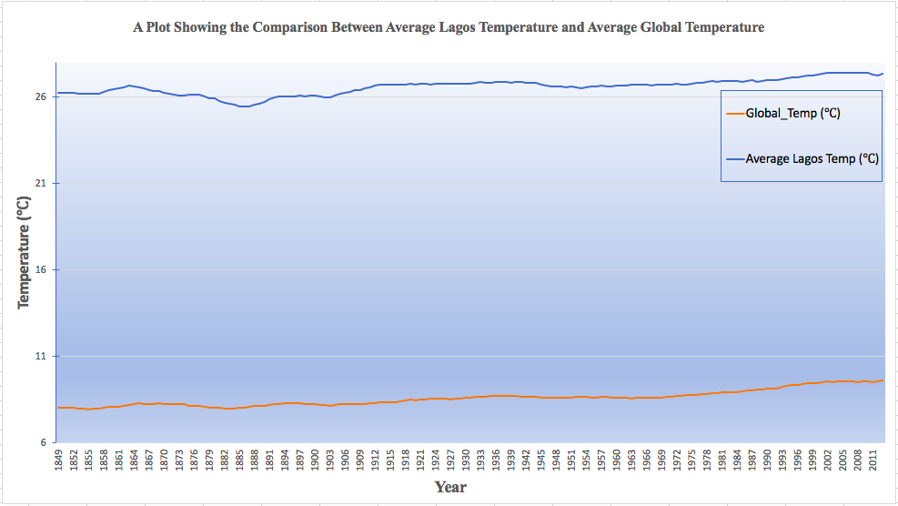

Figure 1: Line Chart of Average Lagos Temperature and Global Temperature

**Observation**

**Similarities in World Average and Lagos Average Temperatures**

1. Over time, there has been a noticeable increase in both temperatures. This is clearly shown on the line graph as both plots show **gentle upslope** from the years 1978 till date.
2. Although there are fluctuations in the temperatures, the general trend is HIGH for both Lagos and Global average temperatures.
3. The last few hundred years temperatures were not as high as it is now, in more recent years and this is due to the increased fossil-fuel activities of man and global warming. This shows the world is getting hotter.
4. The correlation coefficient between Lagos city average temperature and global average temperature is **0.77187478.**

**Differences Between World Average and Lagos City Average Temperatures**

|  |  |  |
| --- | --- | --- |
| S/N | Lagos City Average Temperatures | Global Average Temperature |
| 1. | With an average temperature of 24.3°C, it is relatively hotter than global average temperature. This has been consistent over time | With an average temperature of 8.55°C, it is relatively cooler than Lagos average temperature. This has been consistent over time. |

**Reference**

<https://www.distance.to/Lagos>

<https://www.washingtonpost.com/news/capital-weather-gang/wp/2018/04/26/global-temperatures-have-cooled-since-2016-heres-why-thats-normal/>